

SILVER JUBILEE GOVT. COLLEGE KURNOOL
(Constituent college, Cluster University, Kurnool)

Project Report
On
BOOK WEBSITE

Under the guidance of
Dr H Akther Banu
Lecturer in English

Submitted by
1. B.Madhavi - 21210
2.B.Nandini bai - 21209
3.B.Nikhil - 21208
4.B.Prabhavathi - 21207
5.C.Ravi kumar - 21211

CERTIFICATE

Certified that this is a bonafide record of the project work titled
BOOK WEBSITE
Done By:

B.Madhavi

B.Nandini bai

B.Nikhil

B.Prabhavathi

C.Ravi kumar

of VI semester BSC in the year 2024 in

partial fulfillment of the requirements for the award of Degree of Bachelor of Computer Science

Project Guide Head of the Division

ACKNOWLEDGEMENT

We take this occasion to thank God, almighty for blessing us with his grace and taking our endeavor to a successful culmination. We extend our sincere and heartfelt thanks to our esteemed guide, Dr H Akther Banu, Lecturer in the Department of English, for providing us with the right guidance and advice at the crucial junctures and for showing me the right way. We also take this opportunity to express a deep sense of gratitude to Dr VV Subrahmanya Kumar, Principal, Silver Jubilee Government College . We would like to thank our friends and family for the support and encouragement they have given us during the course of our work.

PROJECT REPORT ON BOOK WEBSITE

TABLES OF CONTENT

Abstract
1.INTRODUCTION
1.1 Project Aims and Objectives
1.2 Background of Project
1.3 Operation Environment
2.SYSTEM ANALYSIS
2.1 Software Requirement Specification
2.2 Existing Vs Proposed
2.3 Software Tool Used
3. SYSTEM DESIGN
3.1 Table Design
3.2 Data Flow Diagrams
4. SYSTEM IMPLEMENTATION
4.1 Snippets of coding
4.2 Screen Shots
5. SYSTEM TESTING
5.1 Unit Testing
5.2 Integration Testing
6.CONCLUSION & FUTURE SCOPE
7.REFERENCES

Abstract

Book Website

The book website is a user-friendly wed-based platform that allows book lovers to browse, search for, and purchase books online. It serves as a virtual bookstore, offering a wide collection of books across various genres, authors and publishers. The platform aims to provide a convenient and seamless books buying experience for customers while promoting reading and literature.
Customers can easily find a book by searching a book title or other criteria like price, author name and customers can add their favorite books into cart and can purchase easily using online payment method. People can share their view through feedback forms and by book reviews.
This platform is easy to use with simple navigation and search features. The principle of book website is providing convenience and service to people. We prioritize organizations of books by catalogs and categories, ensuring everyone feels welcome and Purchase. Come, explore and gain knowledge at book website.

Features of book website
- Broad collection of books: This website offers wide collection of books.
- Reader-Friendly user –Interface: People can access this website through different devices like mobile ,laptop, tablets. This website is mobile compatibility.
- Searching and Filtering: Allows customers to easily find the books they are looking for.
- Adding to Carts: Customers can able to add their favorite books into cart.
- Sharing Option: People can share this website to other social media platforms.
- Payment and Security :The payment process should be secure and support various payment methods ,such as credit cards, online banking, digital wallets. And customers receive confirmation email after completing order.
- User Account :Users can create account for easier future purchases.
- Reviews and feedback forms: Customers can share their view through feedback forms and reviews.
- Customer Support: If any inconveniency occurs , users can contact team members through chat ,email and contact numbers.
- Privacy and Security: The system should clearly outline its data privacy policy and ensures the protection of personal and payment information.

CHAPTER 1
INTRODUCTION
This chapter gives an overview about the aim ,objective ,background and operating environment of the system
1.1 PROJECT AIMS AND OBJECTIVES
The aim of an online book store is to provide customers with provide customers with a convenient and efficient way to purchase books.
It can also offer a wider selection of books than a traditional brick-and-mortar bookstore, and it can often offer lower prices.
2.2 BACKGROUND OF PROJECT
The main purpose of a bookstore is to provide a place for people to discover ,explore, and purchase different types of written content . Whether it's fiction, non-fiction, self-help, or educational materials, a bookstore is where people can go to find all these options in one location.
CHAPTER 2
SYSTEM ANALYSIS
In this chapter, we will discuss and analyze about the developing process of Book website including software requirement specification (SRS) and comparison between existing and proposed system . The functional and non functional requirements are included in SRS part to provide complete description and overview of system requirement before the developing process is carried out. Besides that, existing vs proposed provides a view of how the proposed system will be more efficient than the existing one.
2.1 SOFTWARE REQUIREMENT SPECIFICATIO
GENERAL DESCRIPTION:
The Books website is a web application which is designed and developed to help the customers to purchase different categories of books from the publishers all over the world. The main objective of this system is to make available the various genres of books of different authors from the world to customers by sitting in one particular place. In the proposed system different kinds of e-books can also be purchased and downloaded by the customers. There are three users of this system that is admin, book seller and customer. The admin can add the book sellers, authors and categories of books to the store. The book sellers or publishers can add various genres of books. The customers or the visitors of the web page can view the various books and if they wish to purchase the book then they have to register and login to the system. The admin is one who manages the entire webpage and monitors all the users as well as the activities of the webpage. This project is a very nice student project and neatly designed project developed using PHP (PHP: Hypertext Preprocessor) and MySQL
PROBLEM STATEMENTS:
- Limited reach: Physical bookstores are only present in certain locations, which means that authors may not be able to reach readers who live outside those areas.
- Limited control: Authors may have less control over the placement and promotion of their books in bookstores, as these decisions are often made by store managers and employees.
- Limited profits: Authors may earn less money from book sales in bookstores due to the high overhead costs associated with running a physical store.
- Limited personal interaction: Authors miss out on the opportunity to connect with their audience face-to-face through events and readings
- Competition: Online marketplaces are highly competitive, and it can be challenging for authors to get their books noticed amidst the millions of other titles available.
- Dependence on online platforms: Authors may be reliant on online platforms like Amazon to sell their books, which can limit their control over their sales and marketing efforts.
SYSTEM OBJECTIVES:
- Wide reach: Online retailers allow authors to sell their books to a global audience, regardless of location.
- Flexibility: Authors have more control over the pricing and promotion of their books on online platforms, which can help them increase their profits.
- Convenience: Online sales are convenient for both authors and readers, as they can be made from anywhere with an internet connection.
SYSTEM REQUIREMENTS
FUNCTIONAL REQUIREMENTS
Scenario 1: Browsing and Search
- I want to browse books by various genres, authors, and bestsellers.
- The system should offer a powerful search feature to quickly find specific books by title, author, or keywords.
- I need to be able to filter results based on factors like format (ebook or physical book) and price range.

Scenario 2: Book Details and Review
- I want to see detailed information about each book, including cover image, synopsis, author bio, and publication details .
- Customer reviews and ratings should be prominently displayed to help me make informed decisions.
Scenario 3: Adding to Cart
  - I should be able to easily add books to my virtual shopping cart.
  - The cart should show a clear summary of selected items, including titles, quantities, and prices.
  - I want the ability to adjust quantities or remove items from the cart.
Scenario 4: Checkout Process
  - I want a straightforward checkout process that guides me through each step.
  - I need to provide or verify my shipping address and payment information.
  - The system should display a clear order summary before I confirm the purchase.
  - If available, I want to apply any valid promo codes or discounts to my order.
Scenario 5: Payment and Security
  - The payment process should be secure and support various payment methods, such as credit cards, digital wallets, and online banking.
  - I want to receive a confirmation email after completing the order, including order details and an estimated delivery date.
Scenario 6: Order Tracking
  - After placing an order, I want the ability to track the status of my shipment.
  - The system should provide updates on order processing, shipping, and delivery.
Scenario 7: Customer Support
  - I need access to customer support options, such as live chat, email, or a toll-free number, in case I have questions or encounter issues with my order.
  - The system should provide clear instructions on how to request returns or refunds if needed.
Scenario 8: User Account
  - I want the option to create a user account for easier future purchases.
  - My account should store my order history, shipping addresses, and payment preferences.
  - I should be able to manage my account settings and preferences.

Scenario 9: Mobile Compatibility
  - The online ordering system should be responsive and accessible on mobile devices for convenient browsing and purchasing on the go.
Scenario 10: Privacy and Data Protection
  - The system should clearly outline its data privacy policy and ensure the protection of personal and payment information..
NON FUCTIONALITY REQURIMENT
1.RELIABILITY REQUIREMENT
- The system should accurately performs member registration ,member validation , report generation, book transaction and search.
2.IMPLEMENTATION REQUIREMNTS
- In implementing whole system it uses html in front end with php as server side scripting language which will be used for database connectivity and the backend ie the database part is developed using mysql.
3.DELIVERY REQUIREMENTS
- The whole system is expected to be delivered in six months of time with a weekly evaluation by the project guide.

SOFTWARE AND HARDWARE REQUIREMENTS
This section describes the software and hardware requirements of the system
SOFTWARE REQUIREMENTS
- Operating system- Windows 7 is used as the operating system as it is stable and supports more features and is more user friendly
- Database MYSQL-MYSQL is used as database as it easy to maintain and retrieve records by simple queries which are in English language which are easy to understand and easy to write.
- Development tools and Programming language- HTML is used to write the whole code and develop web pages with CSS, java script for styling work and php for scripting.
HARDWARE REQUIREMENTS

- Intel core i5 2nd generation is used as a processor because it is fast than other
processors an provide reliable and stable and we can run our pc for longtime.
By using this processor we can keep on developing our project without any worries.
- Ram 1GB is used as it will provide fast reading and writing capabilities and will in turn support in processing.
FEATURES OF ONLINE BOOK STORE:
1. They are typically open 24/7, so customers can shop at any time.
2.They also offer a wider selection of books than most physical bookstores.
3.Additionally, online book stores often have lower prices than physical bookstores.
4.The search and filtering options should be user-friendly and allow customers to easily find the books they are looking for.
5. The online bookstore should provide good customer service to answer customer questions and resolve any problems that may arise.

SOFTWARE TOOLS USED

- Express js
- Backend-Mongo-db
- CSS,HTML
- Node.js
- Java Script
- React
ABOUT HTML

Document Type Declaration (<!DOCTYPE html>): This line declares the document type as HTML5, which is the latest version of HTML.
2. <html> Element: This is the root element of the HTML document, and it contains all other elements on the page. The lang attribute is set to "en" to specify that the document is in English.
3. <head> Element: The <head> section contains meta information and links to external resources that are essential for the webpage but not displayed on the page itself. It includes:
- <meta> elements: These define the character encoding (charset), compatibility with Internet Explorer (X-UA-Compatible), and viewport settings for responsive design.
- <title> element: Sets the title of the webpage, which is displayed in the browser's title bar or tab.
- <link> elements: These link to external resources like CSS stylesheets and favicon images.
4. <body> Element: This is the main content of the webpage and contains everything that will be displayed on the page.
5. Header Section (<header>): This section represents the website's header, which includes the site logo, search bar, and navigation links.

6. Navigation Links (<nav>): This section contains navigation links for different sections of the website, such as "home," "featured," "category," "reviews," and "feedback."
7. Bottom Navbar (<nav>): This is a secondary navigation menu, typically used for quick access to specific sections of the page. It contains icons for "home," "featured," "arrivals," "reviews," and "feedback."
8. Login Form: This is a hidden login form that can be toggled by clicking on the user icon in the header.
9. Home Section (<section class="home">): This section contains a promotional banner with a headline, description, and a "shop now" button. It also includes an image slider (created using Swiper) with links to book images.
10. Icons Section (<section class="icons-container">): This section displays icons and descriptions for various features such as free shipping, secure payment, easy returns, and 24/7 support.
11. Featured Section (<section class="featured">): This section showcases featured books using a Swiper slider. Each book is displayed with an image, title, price, and an "add to cart" button.
12. Newsletter Section (<section class="newsletter">): This section allows users to subscribe for updates by entering their email address.
13. Category Section (<section class="arrivals">): This section displays different book categories using Swiper sliders. Each category is represented by an image and a title.
14. Deal Section (<section class="deal">):
This section promotes a "deal of the day" with a discount percentage and a "shop now" button.
15. Reviews Section (<section class="reviews">): This section displays customer reviews using a Swiper slider. Each review includes an image, name, comment, and star rating.
16. Feedback Section (<section class="blogs">): This section provides a link to give feedback.
17. Footer Section (<section class="footer">): The footer contains various boxes with information, quick links, contact details, and social media links. It also includes a credit line for the creators and a copyright notice.
18. Loader: There is a loader with a loading GIF image that will be displayed while the page is loading.
19. JavaScript: The code includes a link to the Swiper library and a custom JavaScript file (script.js) for adding interactivity and functionality to the webpage.

Once the basic HTML structure of the bookstore website is in place, the next step is to add styling to the website using CSS.
Next, we will create our CSS file. In this file, we will use some basic CSS rules to style our website. Let's break down the code section by section:

ABOUT-CSS
1. @import:
- This line imports an external font from Google Fonts (Poppins) and specifies different font weights (100, 300, 400, 500, 600) to be used in the website.
- display: swap is used to ensure that the text content remains visible while the web font is being downloaded.
2. :root:
- Defines global CSS variables (custom properties) to be used throughout the stylesheet. These variables are used to define colors, borders, box shadows, etc., making it easy to maintain and change the site's overall appearance.
3. *:
- This is a universal selector, setting styles for all elements on the page.
- It resets margin, padding, and border-box sizing, removes outlines and borders, and applies text styles like text-decoration and text-transform.
- It also specifies a transition effect for all elements.
4. html:
- Sets the font size to 62.5%, which is a common practice for easier font-size calculations (1rem = 10px).
- Hides horizontal overflow and specifies scroll behavior for smooth scrolling.
- Configures scrollbar styles for webkit-based browsers.
5. section:
- Adds padding to all section elements.
6. .heading:
- Styles for elements with the class "heading."
- Includes text alignment, a horizontal line before the heading, and styling for a span element within the heading.
7. .btn:
- Styles for elements with the class "btn," such as buttons.
- Defines margin, padding, background color, and hover effect.
8. .header:
- Styles for elements with the class "header."
- It defines the appearance of the website's header, including the logo, search form, and icons.

9. #search-btn:
- Styles for an element with the ID "search-btn," presumably a search button.
- Sets it to display:none initially.
10. .bottom-navbar:
- Styles for elements with the class "bottom-navbar," possibly for a navigation bar at the bottom of the page.
11. .login-form-container:
Styles for a container for a login form.
- It specifies the form's appearance, including borders, background, and positioning.
12. .home:
- Styles for elements with the class "home."
- Defines a background image and styles for content within the home section
13. .icons-container:
- Styles for elements with the class "icons-container."
- Defines a grid ayout for icons.
14. .featured:
- Styles for elements with the class "featured."
- It specifies styles for featured items, including image containers, content, and icons.
15. .swiper-button-next and .swiper-button-prev:
- Styles for next and previous buttons used in a swiper/slider component.
16. .newsletter:
- Styles for elements with the class "newsletter."
- Sets a background image for the newsletter section.
17. .arrivals:
- Styles for elements with the class "arrivals."
- Specifies styles for the arrivals section, including images, content, and prices.
18. .deal:
- Styles for elements with the class "deal."
- Defines styles for a deal section, including content and images.
19. .reviews and .blogs:
- Styles for elements with the classes "reviews" and "blogs."
- Specifies styles for review and blog sections, including images and content.
20. .footer:
- Styles for elements with the class "footer."
- Sets styles for the website's footer, including box containers and social share icons.

21. .loader-container:
- Styles for a loader container, used for displaying a loading animation.
22. Media Queries:
- These queries adjust styles based on screen width, making the website responsive for different devices and screen sizes.
This will give our bookwebsite an upgraded presentation. Create a CSS file with the name of styles.css and paste the given codes into your CSS file. Remember that you must create a file with the .css extension.
ABPOUT JAVASCRIPT
JavaScript Code:
Finally, we need to create a function in JavaScript. Let me break down the code for you step by step:
1. DOM Element Selection:
- searchForm is a variable that is assigned the result of selecting an HTML element with the class "search-form" using document.querySelector().
- loginForm is a variable that is assigned the result of selecting an HTML element with the class "login-form-container" using document.querySelector().
2. Button Click Event Listeners:
- When the element with the ID "search-btn" is clicked, a function is executed. This function toggles the "active" class on the searchForm element, which typically changes its appearance or behavior.
- When the element with the ID "login-btn" is clicked, a function is executed. This function toggles the "active" class on the loginForm element.
- When the element with the ID "close-login-btn" is clicked, a function is executed. This function removes the "active" class from the loginForm element, effectively hiding it.
3. Scroll Event Listener:
- When the window is scrolled, a function is executed.
- It first removes the "active" class from the searchForm element.
- Then, it checks if the vertical scroll position (window.scrollY) is greater than 80 pixels. If it is, it adds the "active" class to an element with the class "header-2" inside an element with the class "header". This changes the appearance of the header when the user scrolls down the page.
4. Window Load Event Listener:
- When the window finishes loading, a function is executed.
- Similar to the scroll event listener, it checks the vertical scroll position and adds or removes the "active" class from the same "header-2" element based on the scroll position.
- It also calls two functions, fadeOut() and loader(), although the definition of fadeOut() is not provided in this code snippet.

CHAPTER 3

SYSTEM DESIGN

STEPS TO CREATE BOOK WEBSITE

- Buy a domain name.
- Choose a website builder and hosting service.
- Hire an author website designer.
- Add content to your homepage.
- Set up an email newsletter.
- Create a free resource for your visitors.
- Keep improving the user experience.

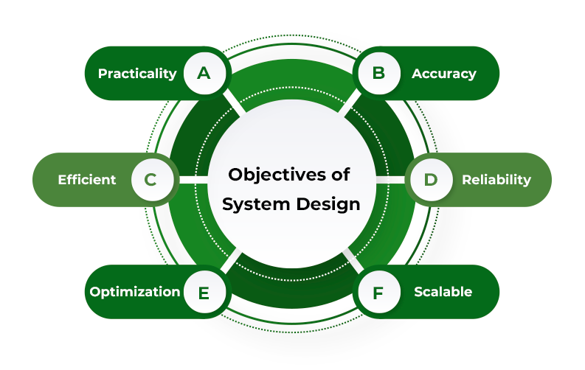

TABLE DESIGN

ER DIAGRAM OF BOOK WEBSITE

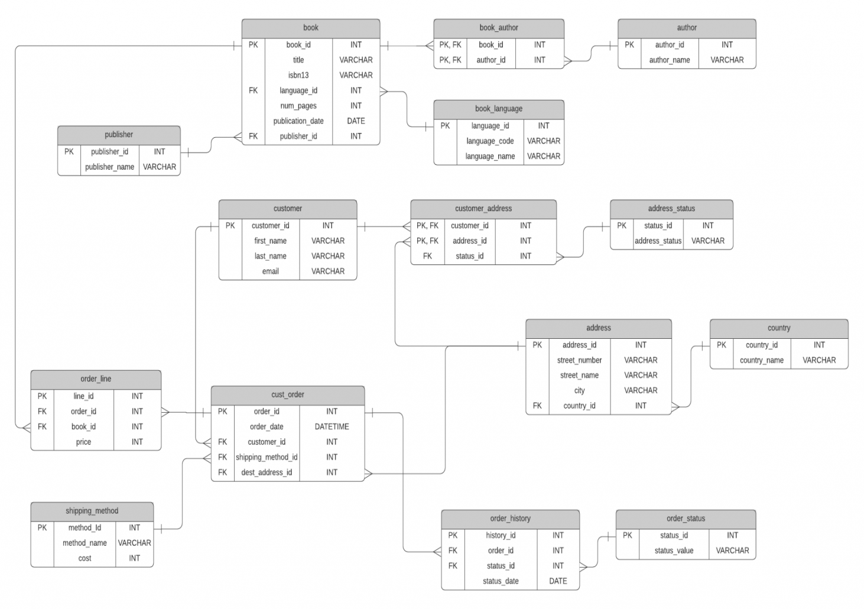

FLOW CHART

1. ZERO LEVEL OF BOOK WEBSITE:

This is first phase of creating book website

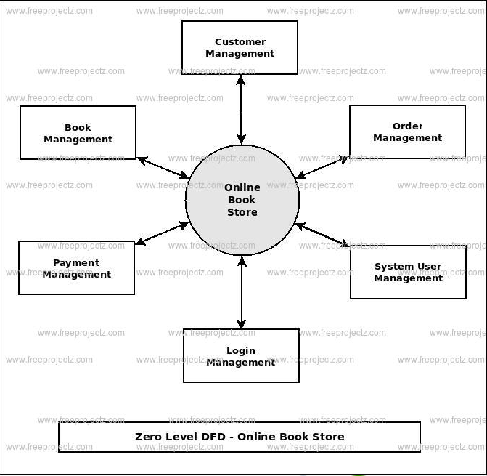

FIRST LEVEL OF BOOK WEBSITE
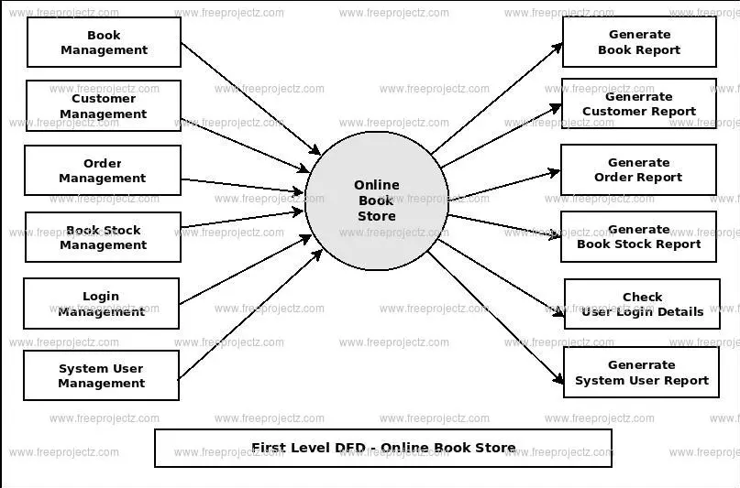
SECOND LEVEL OF BOOK WEBSITE
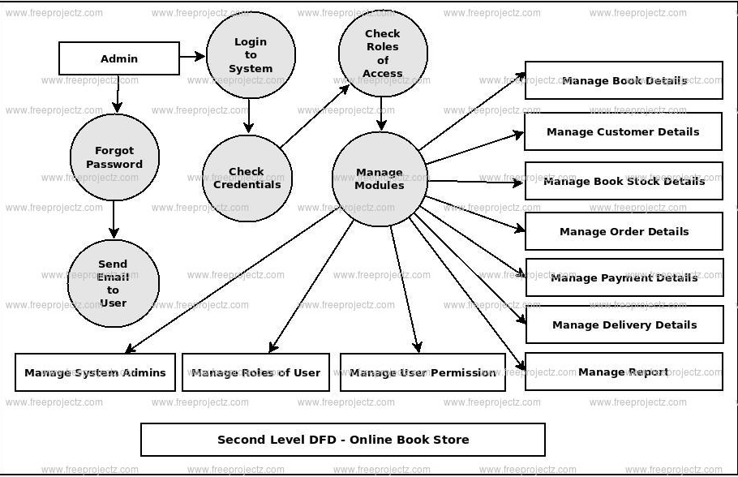
CHAPTER 4
SYSTEM IMPLEMENTION
Snippet Of Html Code
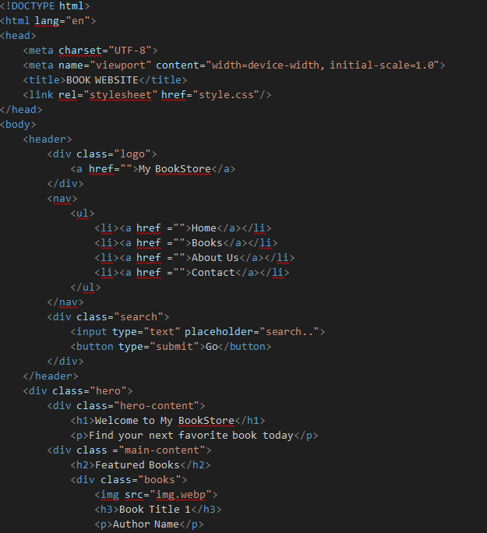

Snippet Of Css Code
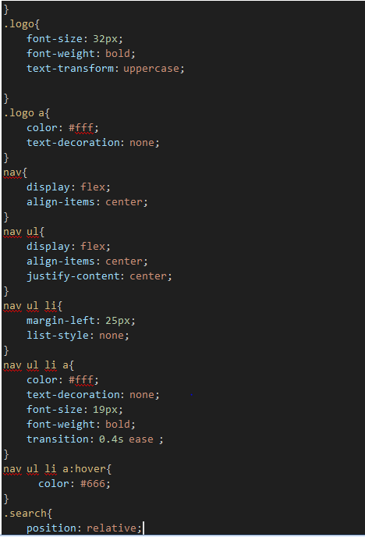
Screenshot 1: Image of Book website

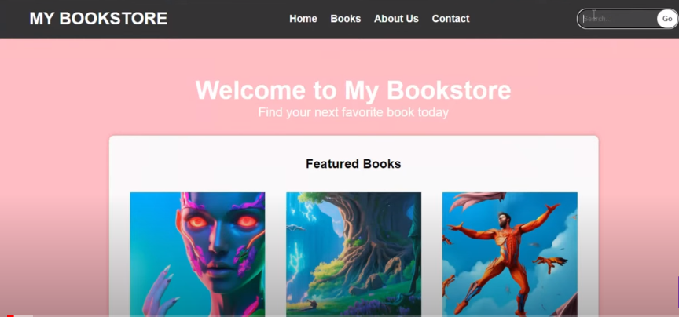

CHAPTER 5
SYSTEM TESTING

The aim of the system testing process was to determine all defects in our project .The program was subjected to a set of test inputs and various observations were made and based on these observations it will be decided whether the program behaves as expected or not. Our Project went through two levels of testing
- Unit testing
2.Integration testing
1.Unit testing
Unit testing is undertaken when a module has been created and successfully reviewed .In order to test a single module we need to provide a complete environment ie besides the module we would require
- The procedures belonging to other modules that the module under test calls
- Non local data structures that module accesses
- A procedure to call the functions of the module under test with appropriate parameters
2. INTEGRATION TESTING
In this type of testing we test various integration of the project module by providing the input.
The primary objective is to test the module interfaces in order to ensure that no errors are occurring when one module invokes the other module.

CHAPTER 6
CONCLUSION AND FUTURE SCOPE
In conclusion, the online book store project was a success. The system was developed on time and within budget, and it meets the requirements of the stakeholders. The system is user-friendly and provides a convenient way for customers to purchase books. The system also has a number of features that make it more efficient than traditional brick-and-mortar bookstores, such as the ability to search for books by title, author, or subject, and the ability to add books to a shopping cart and checkout online.
These events also give customers a sense of community during the COVID-19 pandemic, when many people feel isolated and disconnected. Online books website have become very popular in recent years due to their convenience. E-books were valued at over $19 billion in 2022 and are projects to reach over $33 billion by 2032 .

CHAPTER 7

REFERENCE

1.https://www.google.com
2.https://www.w3schools.com
3.https://github.com/

